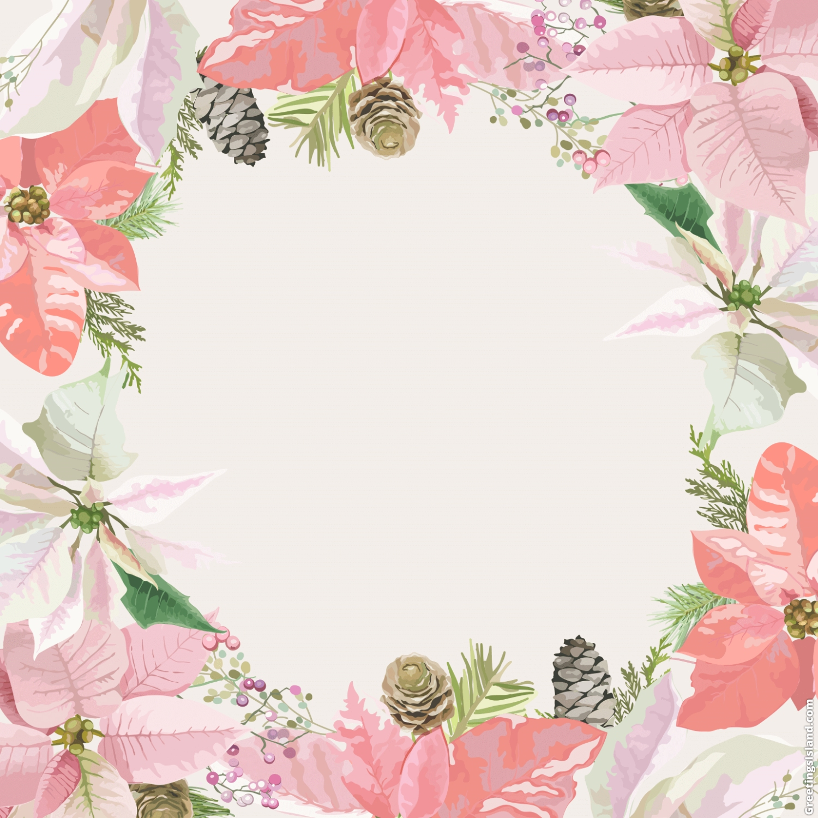

**DIAMOND PACKAGE**

**Php220,000.00 net**

1. Wedding/Debut Coordinator: OTD
2. Lights and Sounds with bubble and fog machine
3. Class A Host
4. Photo/Video Coverage
5. Photo booth: 2 hrs
6. Florist
7. Hair & Make up
8. Catering: Good for 100 pax, 550/pax in excess
9. Entrance Arc/Photowall

**FREEBIES:**

Free use of Bridal Robe

Free use of Mannequin

Free use of 2 easel stands

3-Layer fondant cake (1 layer edible 10”) or 1-Layer edible with 40 cup cakes

Events styling with theme- Stylistic Backdrop with couch, ceiling drapes with lanterns and crystals

Registration area styling

Flowers for reception

Decorated Cage and doves (dove to be returned after the event) –for wedding event

18 Roses for debutante

Red Carpet